Alloa First and Clackmannanshire Council Public Artworks
Application form
Alloa First, in partnership with Clackmannanshire Council, is calling out to Clackmannanshire artists to produce artworks for a gable end and an adjacent wall in a prominent location within Alloa town centre.

Our theme for project designs is ‘Alloa: People and Place’

Alloa First and Clackmannanshire Council would like to commission at least one artist to produce artworks for the gable end wall, and an adjacent wall situated in the lane between Drysdale Street and the King Street carpark. Artists are invited to provide design concepts and costings for each area separately. Designs should be submitted in PDF format (maximum A3 portrait or landscape), along with completed application form.

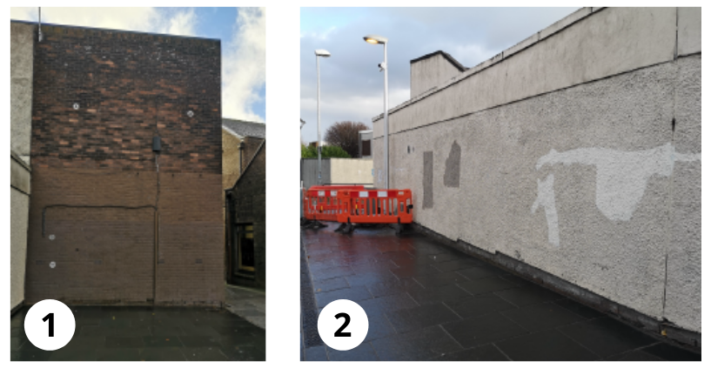
The gable end wall (Wall 1) is approximately 5m in length and 7m in height.
The adjacent low wall (Wall 2) is approximately 13m in length and 2.5m in height.

We are looking for artists who can design, project manage and deliver an original high-quality artwork that will have a positive impact on the town and will engage locals and visitors using this route in and out of the town centre.
Designs should have some relevance to our theme of ‘Alloa: People and Place’ and we are keen to see what types of innovative and inspiring designs come forward.
Entrants must either work or live in Clackmannanshire, or have prominent links to the area.
Applicants must ensure they have all health and safety certification and insurances necessary to complete the commission.
Questions should be directed to Diane Brown at Alloa First on 07866590533 or 01259 211944, or email diane@alloafirst.co.uk
Proposals will be judged on a combination of price, quality, and design proposal and how well it relates to our theme of ‘Alloa: People and Place’.
The decision of the Judging Panel will be final.
Your application(s) can only be considered by submitting artwork in PDF format (maximum A3 landscape or portrait) and by completing the information fields below:
Name:
Address:
(If your address is not in Clackmannanshire, please state your link to the area)
Email:
Telephone:
Design format supplied:
Title of Submission:
Please state which wall this application relates to (each wall will be treated as a separate commission):
Wall 1
Wall 2

Concept and relevance to the area/ people and place link: maximum 250 words
Total Cost (must include preparation of the wall, all materials, equipment, and insurances (excluding VAT). Please break down the separate elements as far as possible:
Additional comments (including any information on previous similar projects): maximum 250 words:

